**WD – JQuery Basic, Effects & Advanced**

**MODULE - 05**

JQuery Basic,

Effects & Advanced

**Submitted To:-**

**Heet Modh Sir**

**Submitted By:-**

**Ankita Sahu**

**Module (JQuery Basic, Effects & Advanced) –** 5

**1) What is jQuery?**

**Ans:-**

JQuery is a small, light-weight and fast JavaScript library. It is cross-platform and supports different types of browsers. It is also referred as ?write less do more? because it takes a lot of common tasks that requires many lines of JavaScript code to accomplish, and binds them into methods that can be called with a single line of code whenever needed. It is also very useful to simplify a lot of the complicated things from JavaScript, like AJAX calls and DOM manipulation.

* jQuery is a small, fast and lightweight JavaScript library.
* jQuery is platform-independent.
* jQuery means "write less do more".
* jQuery simplifies AJAX call and DOM manipulation.

**2) How to Apply CSS Using JQuery, How to Add Class and Remove Class in Jquery , JQuery Animation?**

* How to Apply CSS Using JQuery

**Code:-**

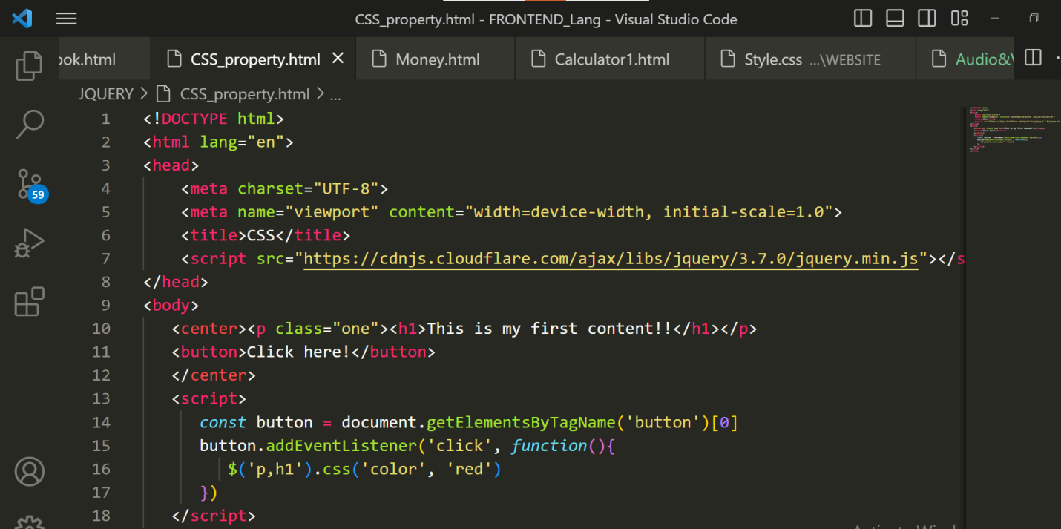

**Output:-**

**Before apply Css:**

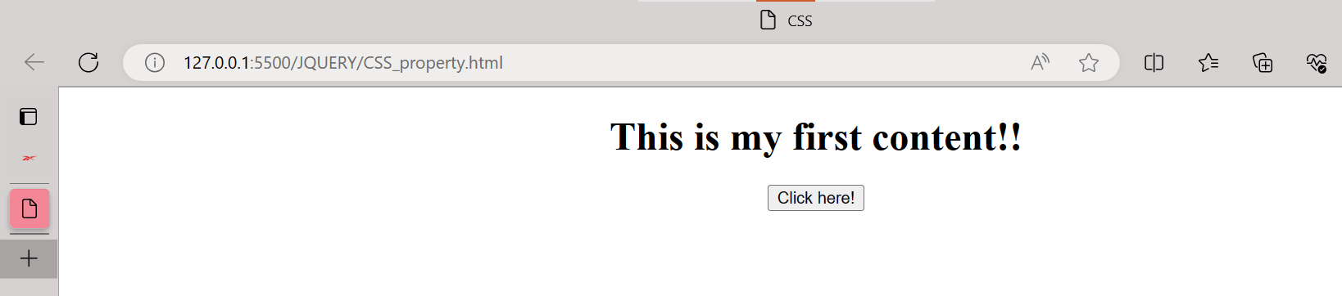

**After apply Css:**

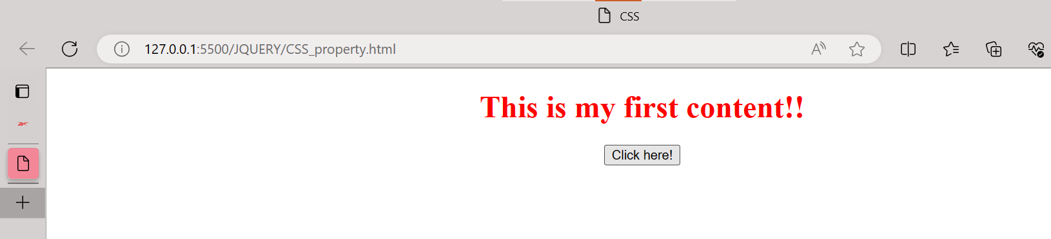

* How to Add Class and Remove Class in Jquery

**Add Class:**

**Code:-**

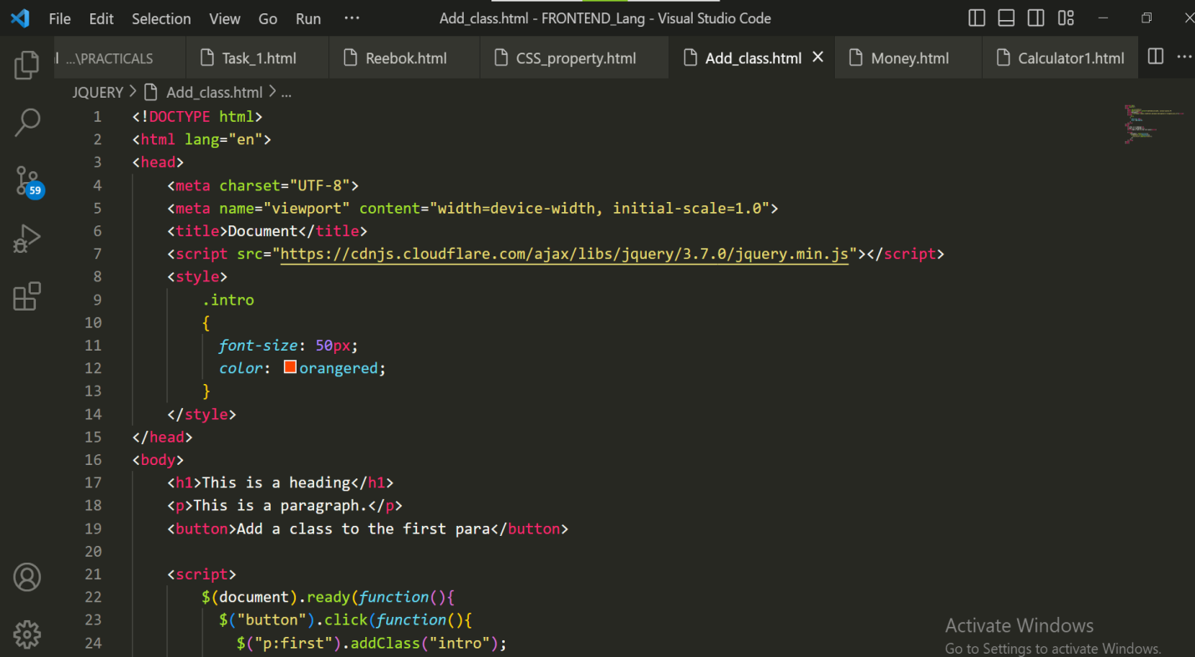

**Output:-**

**Before Add class:**

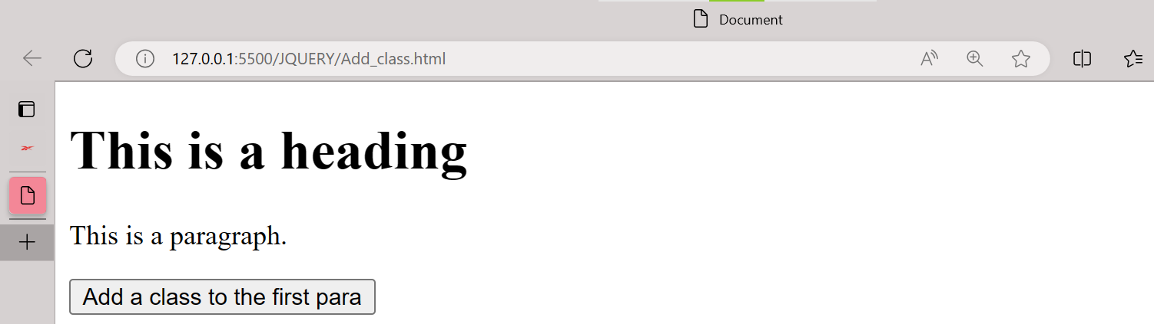

After Add Class:

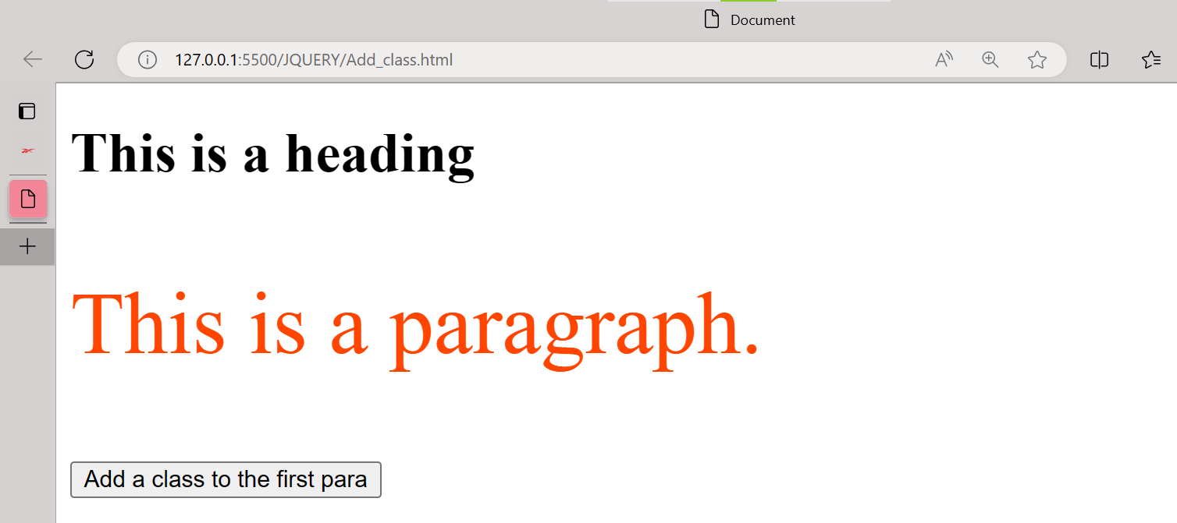

Remove Class:

**Code:-**

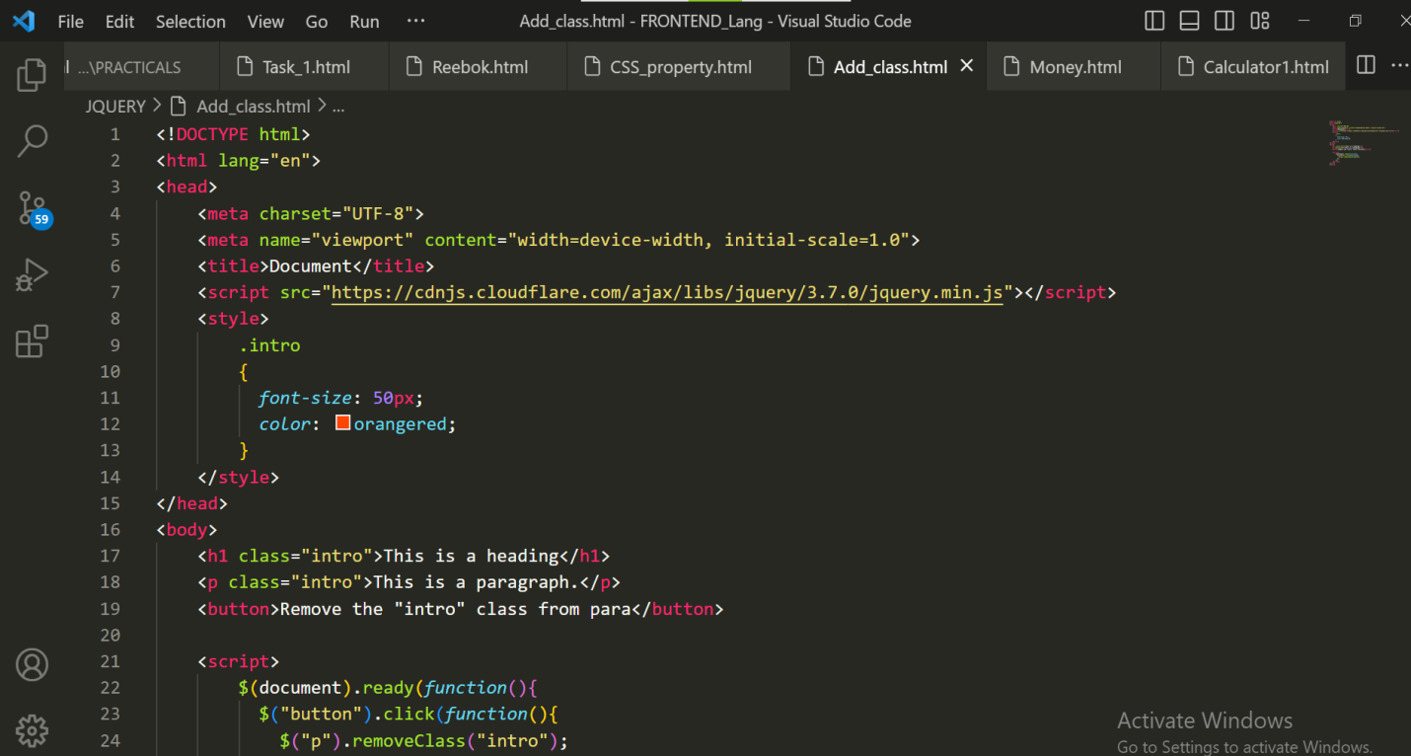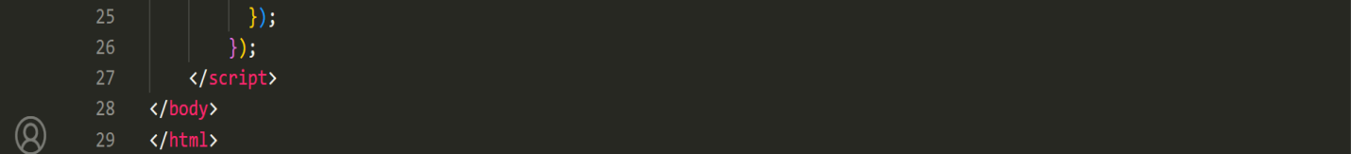

**Output:-**

**Before Remove Class:**

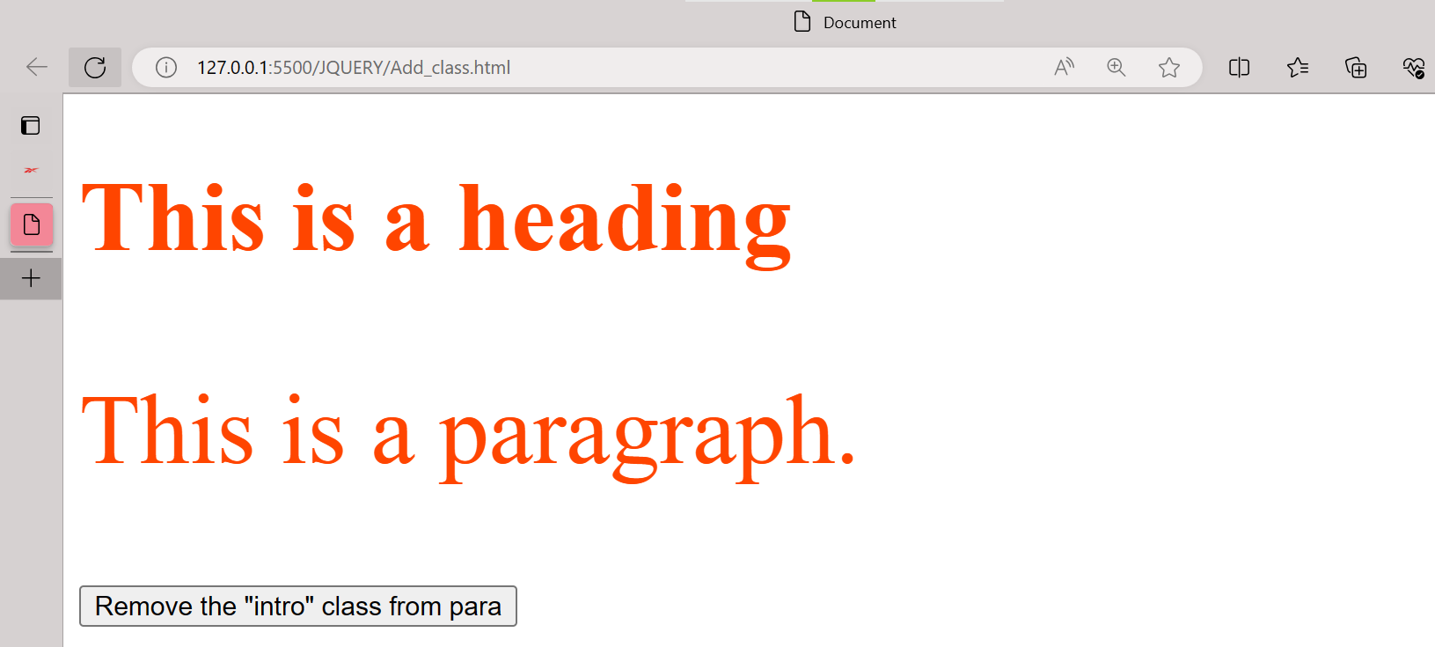

**After Remove Class:**

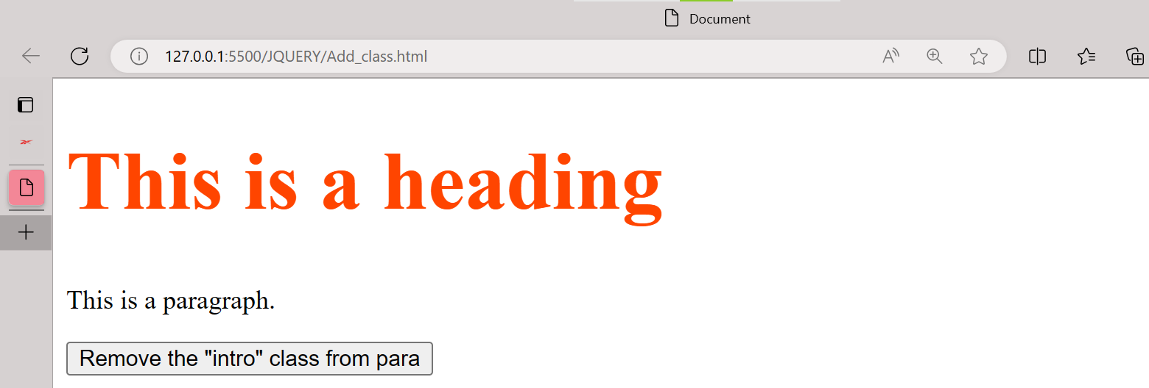

JQuery Animation

**Code:-**

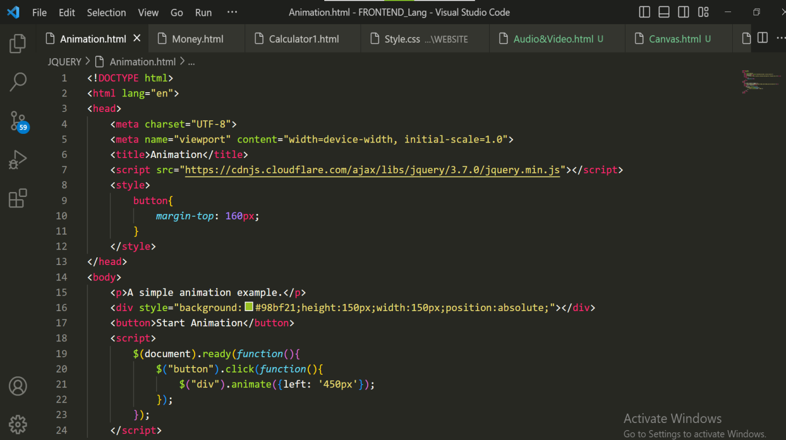

**Output:-**

**Before Animation:**

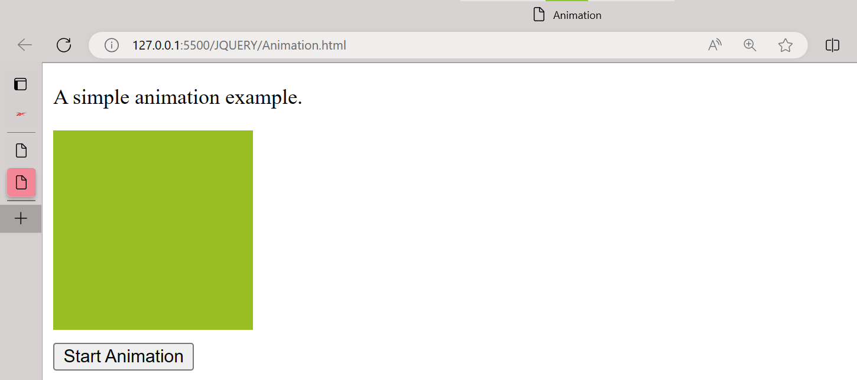

**After Animation:**

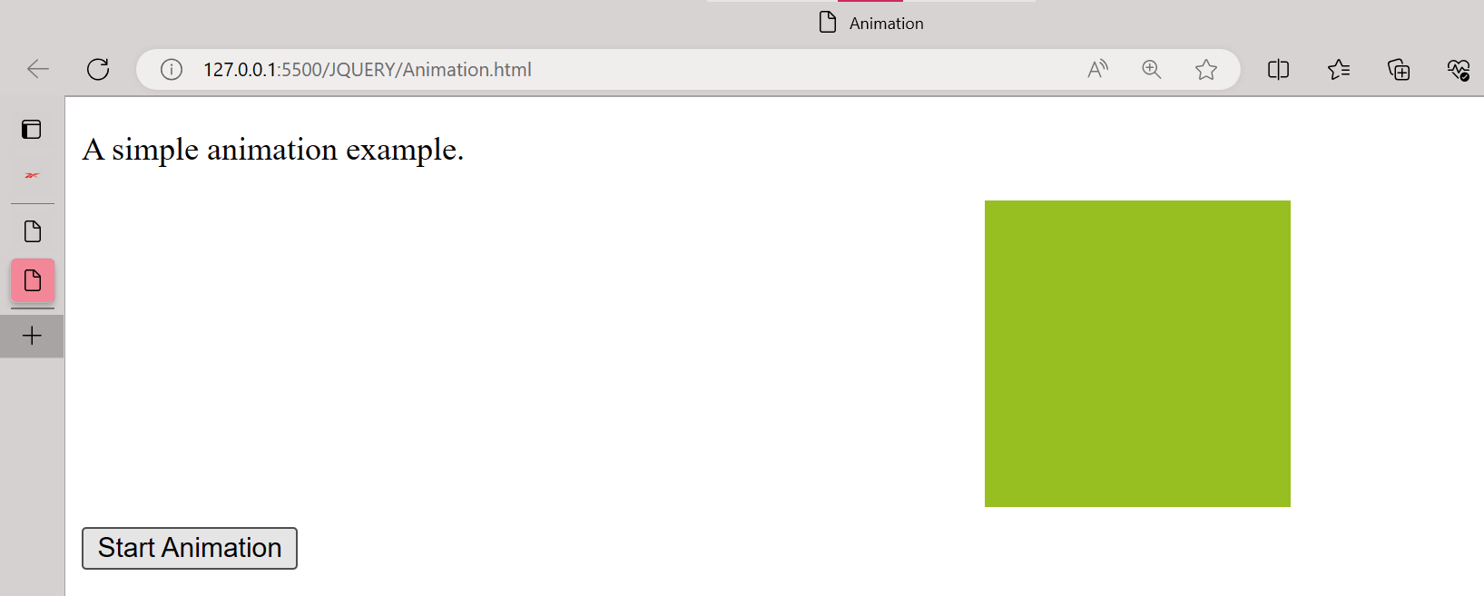

**3) How to create slider with animation?**

**Code:-**

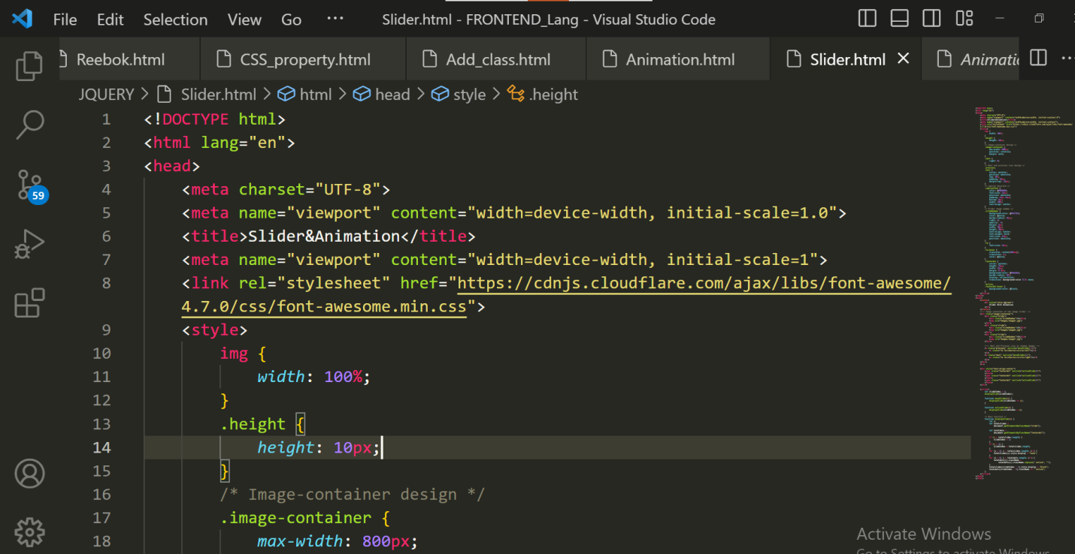

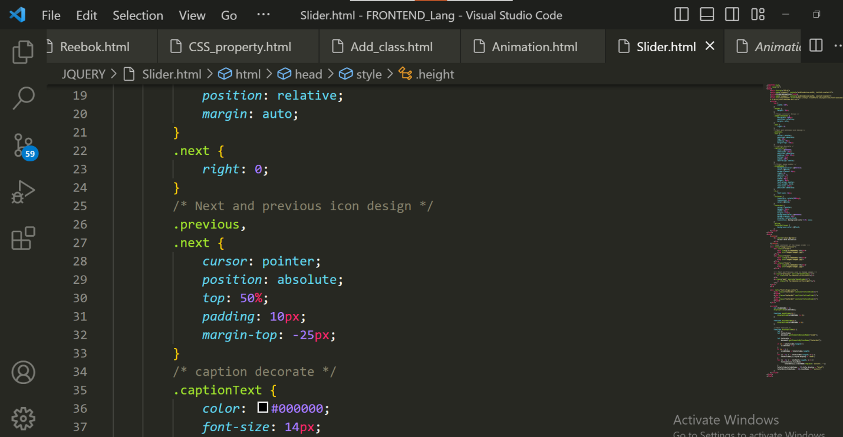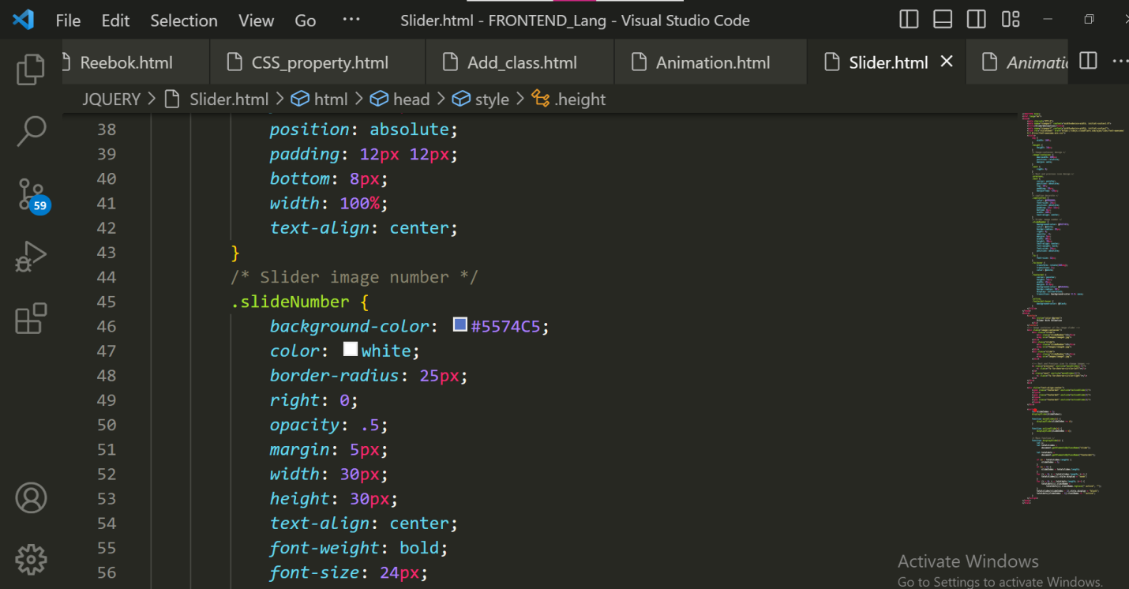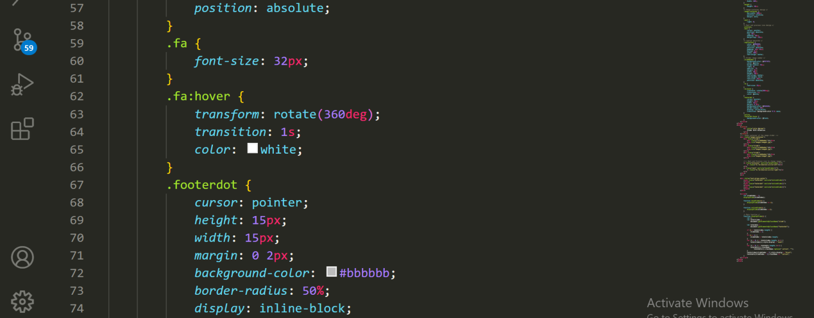

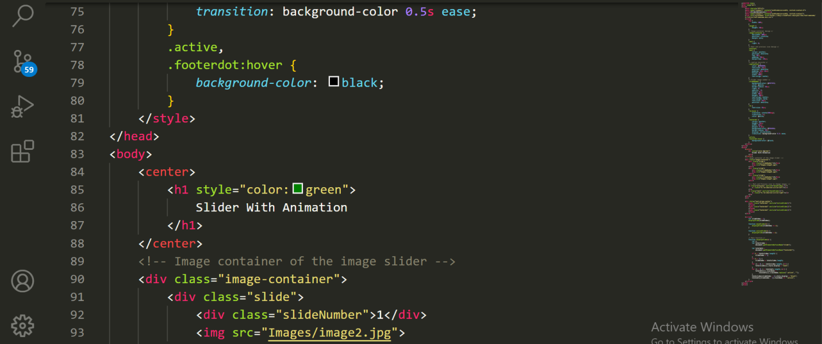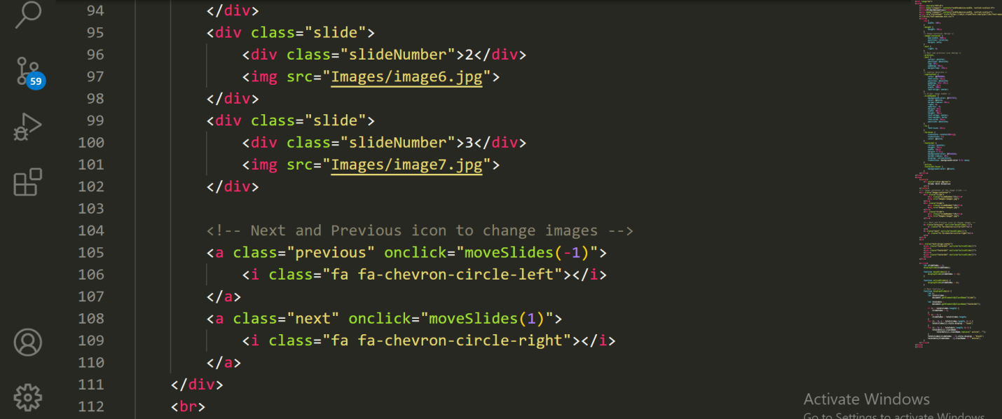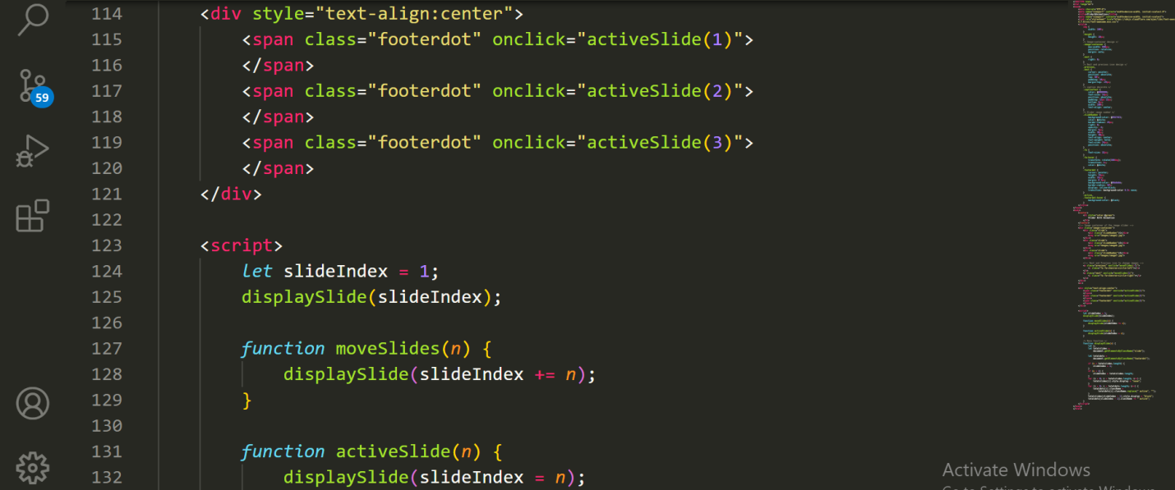

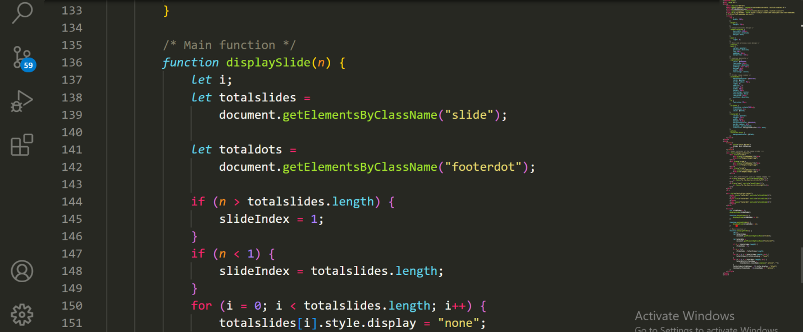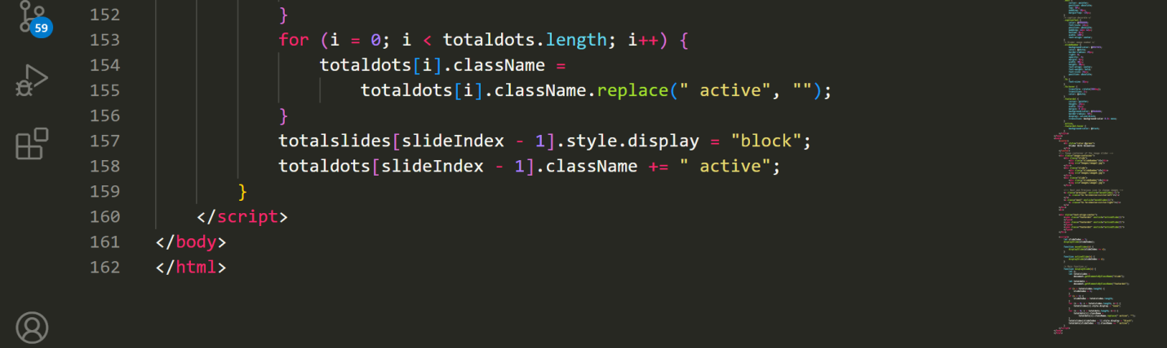

**Output:-**

**Slider-1:**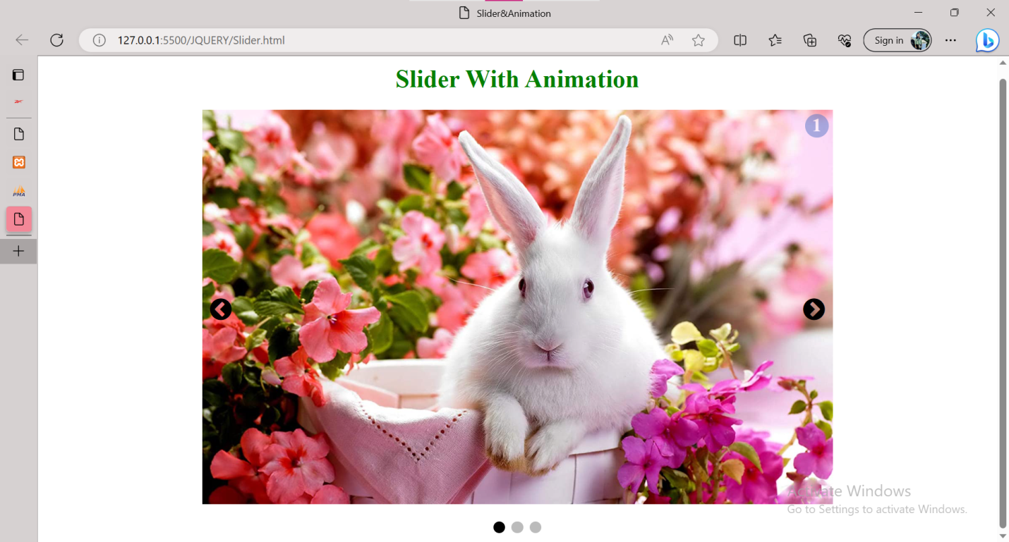

**Slider-2:**

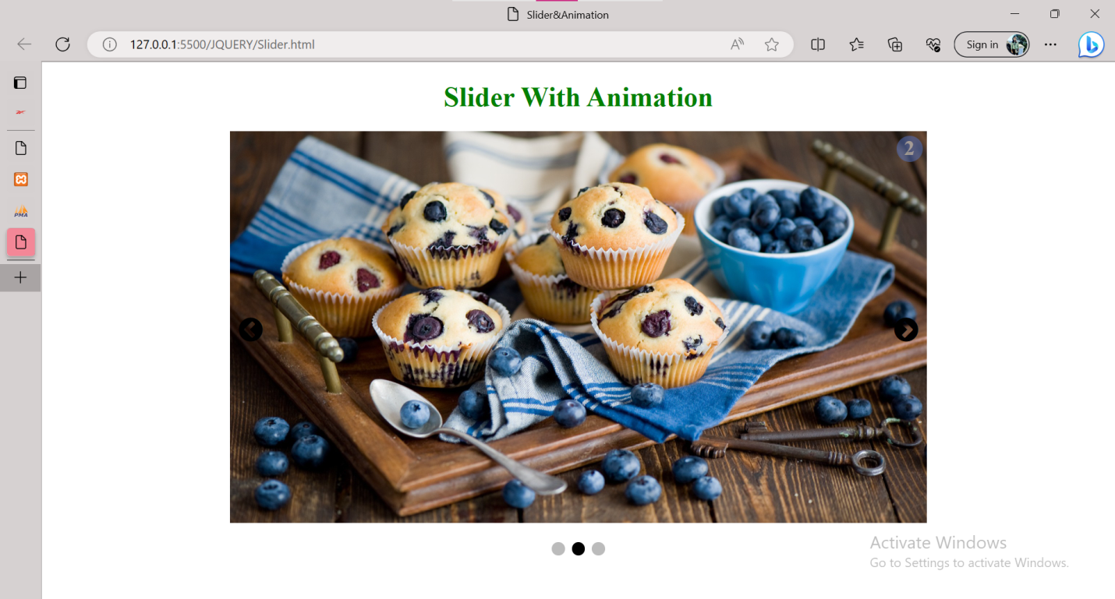

**Slider-3:**

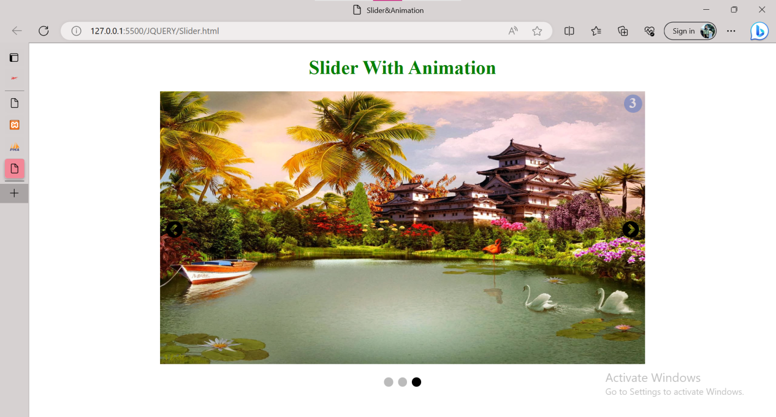

**XOXOXOXOXOXOX**